EMAIL: dbulger@clearpathne.org for complete information packet and instructions for applying. Please include Dogs2Vets in the subject line Thanks you

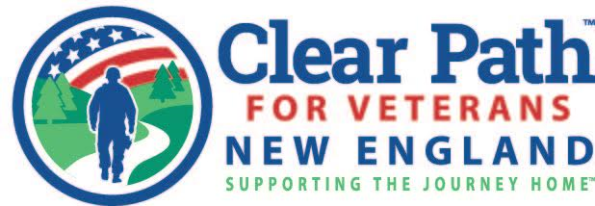
Dear Applicant,
Hello and thank you for your interest in our Dogs2Vets program at Clear Path for Veterans. Included with this letter is your registration packet. In addition to the packet, the Dogs2Vets program requires the following to be accepted into the program:
- Application
- Completed registration packet (checklist below)
- Initial interview at Clear Path
- Successful completion of the prescreening
- Potential dog match (if appropriate)
- Assignment to your one on one trainer (this is the stage of official enrollment)
We are excited to begin your training with us. The following items are needed to complete your registration packet for the program. Some of these items are only required if you are applying for service dog training or if you already own a dog you would like to use for the program. These are noted below as well. Please contact us if you have any questions regarding your items due.
- Two character references. These may be from friends, family, co-workers, fellow service members, etc. Please have your references mail it directly to us.
- IF YOU RENT: Landlord permission to have a dog at your home. Remember to inform your landlord that this will be an Emotional Support animal or Service dog in training. (There are no additional costs that a landlord may legally require for this.) N/A if you own your own home.
- Therapist letter of support. Find enclosed the pages to give to your therapist. One is a template for what your therapist should include in his/her letter. This is only required if your goal in the program is to complete program resulting in a trained service dog.
- Copy of your DD214. Please block out your SSN#. This is proof of service.
- Proof of service connected disability, disability breakdown. This can be printed from the internet using Ebenefits.
- Financial worksheet. There is no cost to our program but it does require that you have the finances to care for your dog and to maintain reliable transportation to our facility on a weekly basis.
- Emergency consent form.
- Video/photo release form. The use of photos/videos of you is voluntary.
- Veterinary health report. This is only required if you already own a dog you are using for the program or have a dog that will be living with a dog we are obtaining for you. This is also the form we use when adopting a dog for you. Please note that we cannot enroll you in the introductory class (for preprogram screening) until we have your dog’s record of up to date vaccinations.
- Baseline survey (SU sponsored). This is for research purposes only and we do not use your name when reporting results.
- Social contract. This agreement is between Clear Path and the Veteran concerning basic care of the dog. It is specific to whether you own the dog or we provide the dog for you.
- Cancellation policy. Our policy concerning cancellations.
- Photo of Veteran and your dog if applicable. This is for internal use only.
All these items are due within two weeks of your initial interview (Date: __/__). They are required to enter the program and stay on the waitlist. If you need an extension, please let our Dogs2Vets staff know as soon as possible.
Please note, during the program you will be required to follow the steps directed by our training staff. This includes when it is ok to start using your dog in public spaces, the use of a vest. Remember you represent all those using service dogs so appropriate use at the right time is imperative to giving properly trained dogs legitimacy.
Thank you for your service. We look forward to working with you.

Best,
Clear Path for Veterans New England Dog Team
Email: dbulger@clearpathne.org

